PEAK PROPULSIVE POWER

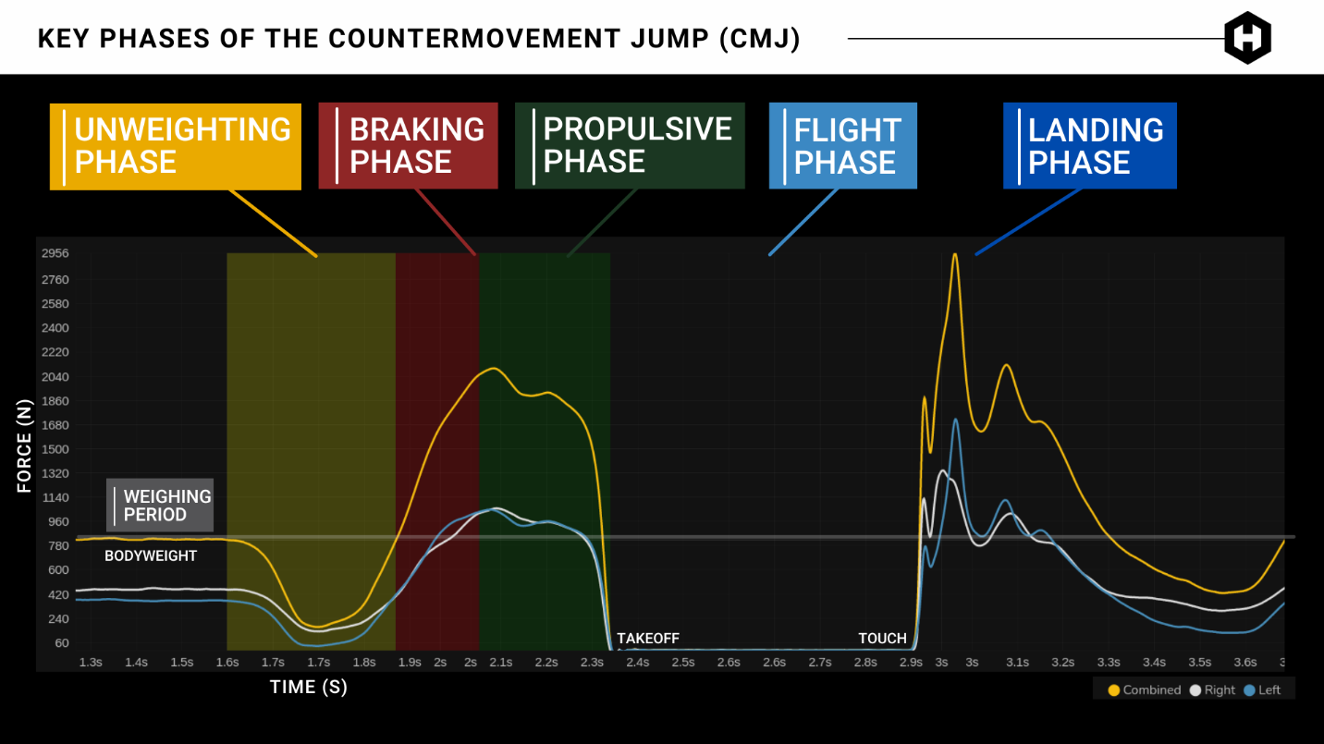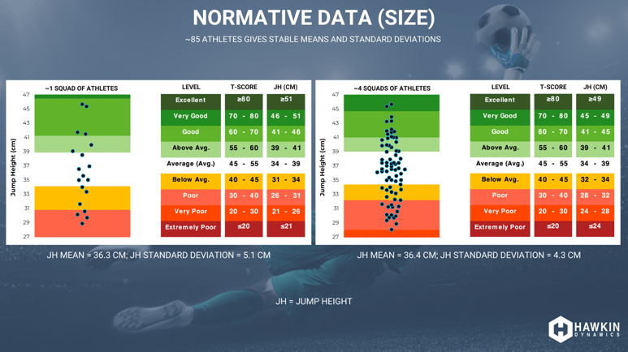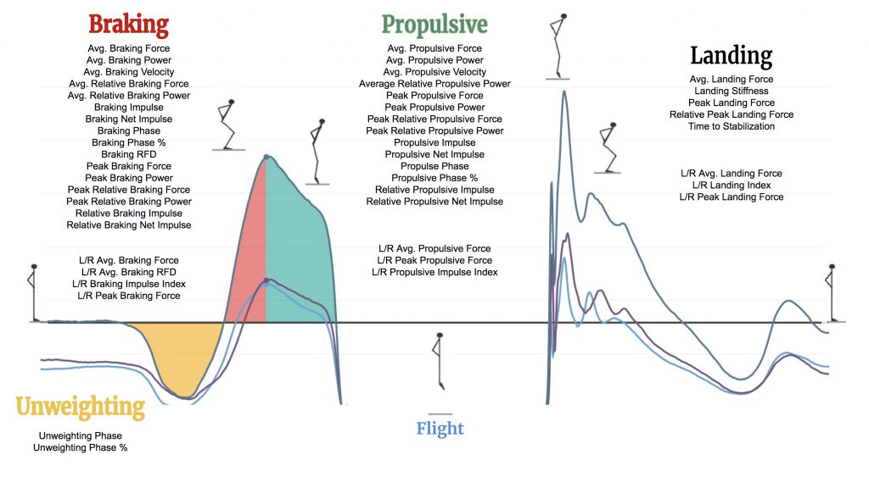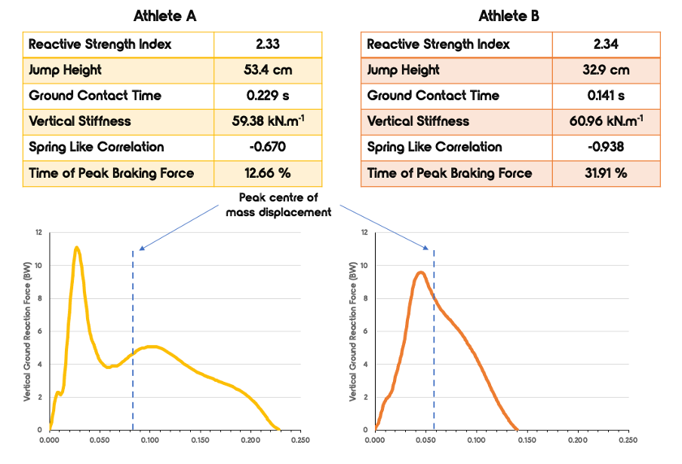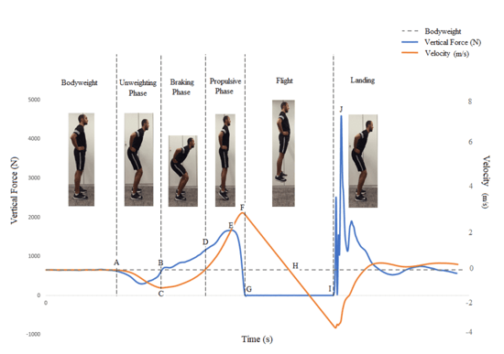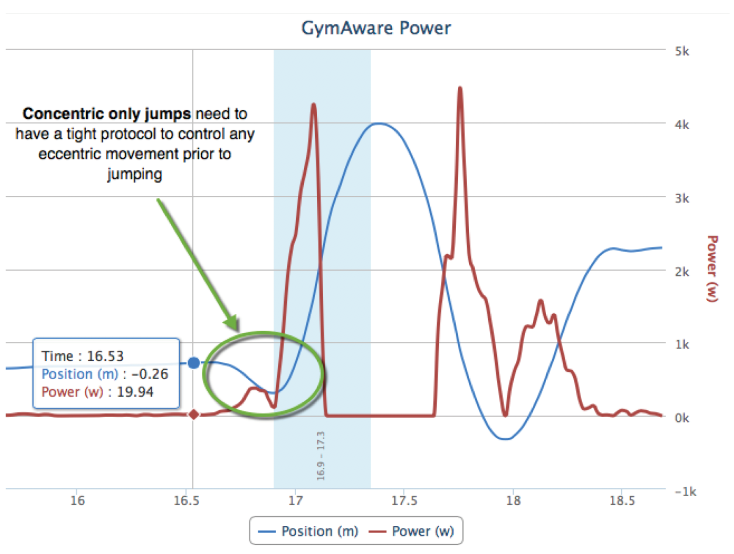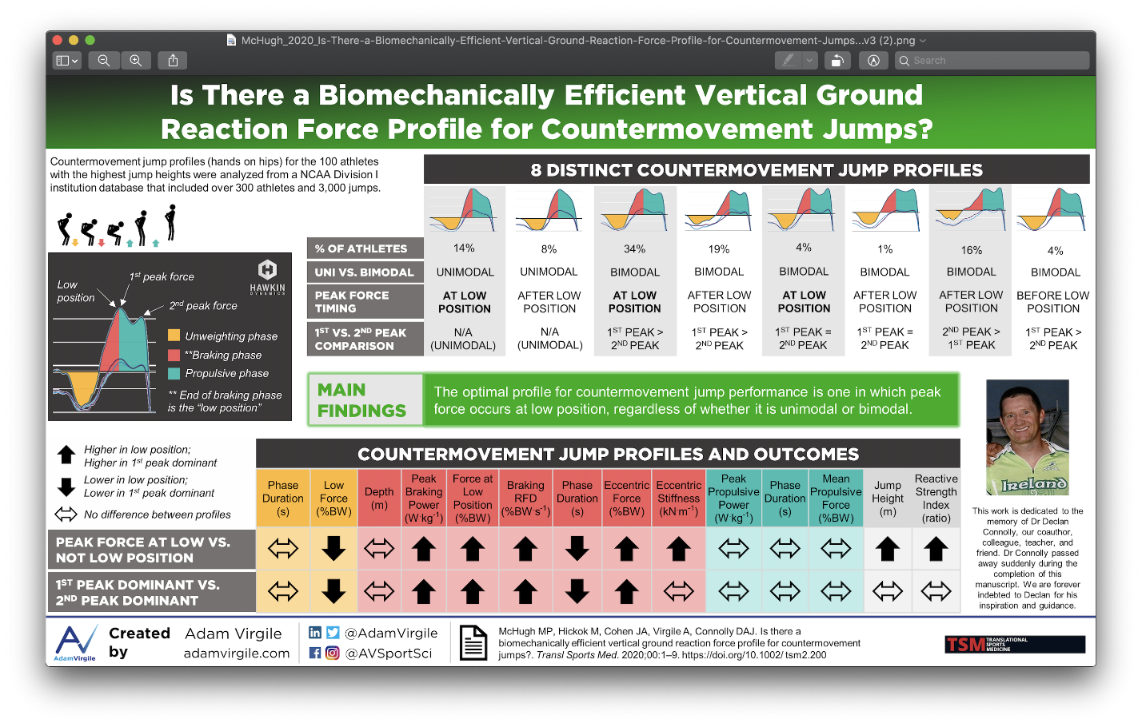
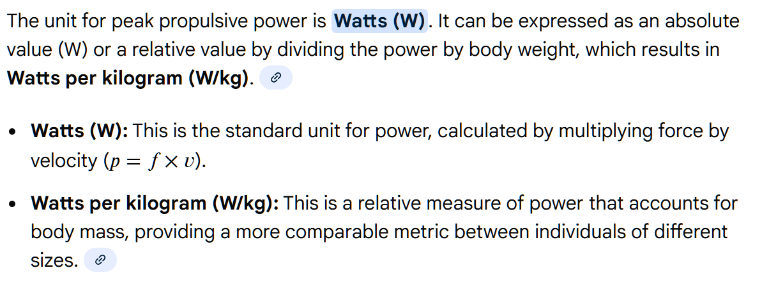
- https://www.researchgate.net/publication/312086103_Peak_versus_mean_propulsive_power_outputs_which_variable_is_more_related_to_jump_squat_performance
- https://www.vbtcoach.com/blog/is-everything-we-know-about-vbt-wrong#:~:text=Power%20metrics,accurately%20profiling%20with%20multiple%20sets.
- https://gymaware.zendesk.com/hc/en-us/articles/333757013756-Parameters-explained-measurement-metrics#:~:text=Conc%20Peak%20Power%20(W),f=%20force%20and%20v=velocity

